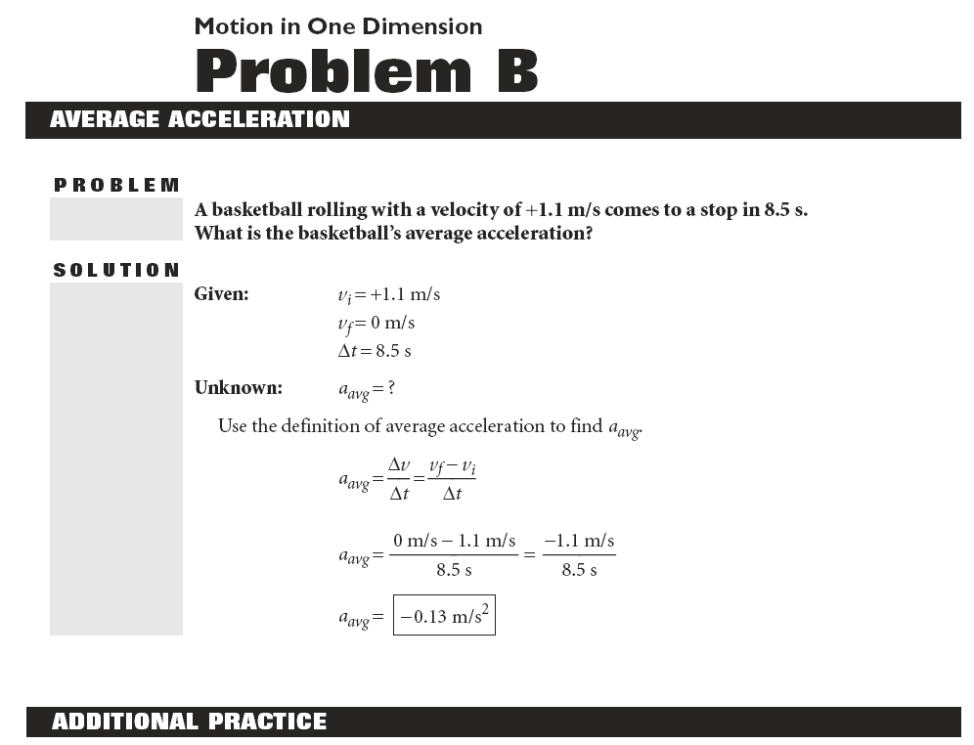
Name ______________________

HW

Forestville Central School • Regents Physics

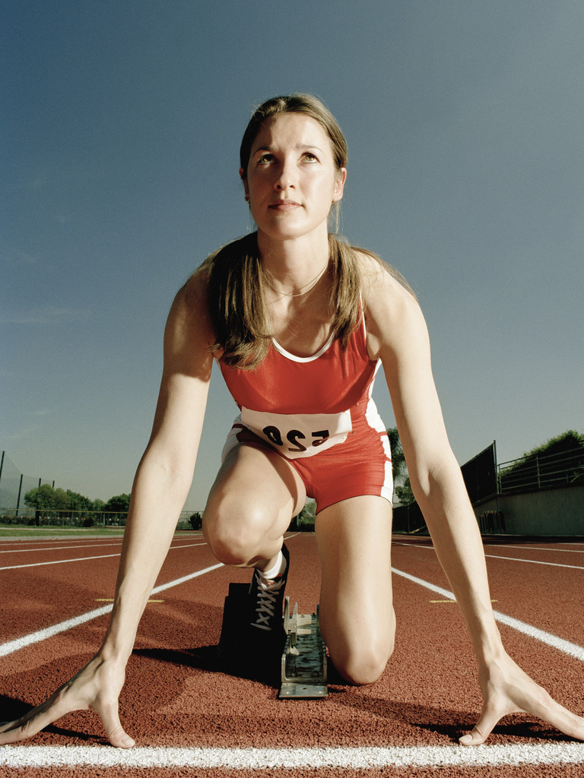
1. With a time of 6.92 s, Irina Privalova of Russia holds the women’s record for running 60 m. Suppose she ran this distance with a constant acceleration, so that she crossed the finish line with a speed of 17.34 m/s. Assuming she started at rest, what was the magnitude of Privalova’s average acceleration?

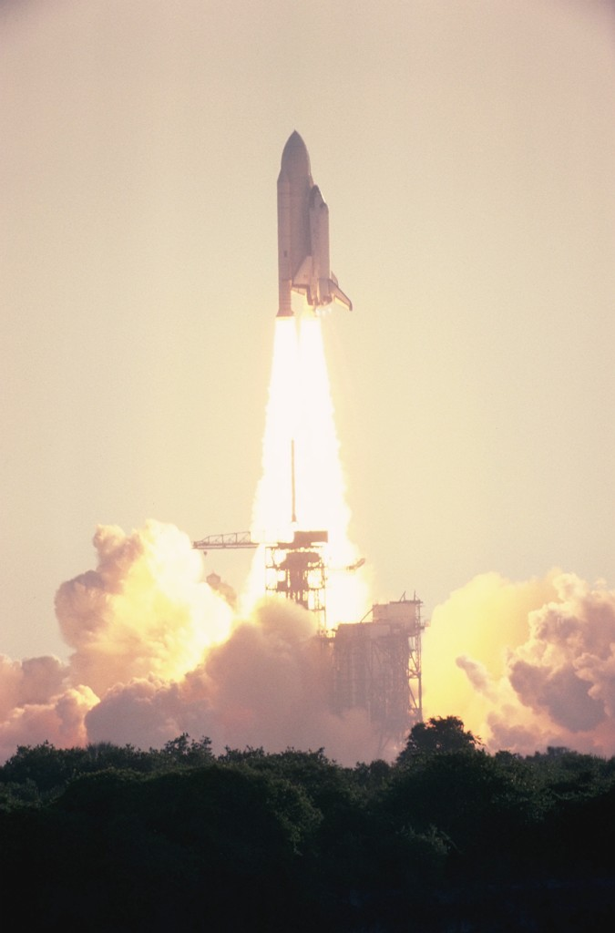
2. The solid-fuel rocket boosters used to launch the space shuttle are able to lift the shuttle 45 kilometers above Earth’s surface. During the 2.00 min that the boosters operate, the shuttle accelerates from rest to a speed of nearly 7.50 x 10² m/s. What is the magnitude of the shuttle’s average acceleration?

3. In 1970, Don “Big Daddy” Garlits set what was then the world record for drag racing. With an average acceleration of 16.5 m/s², Garlits started at rest and reached a speed of 107.2 m/s. How much time was needed for Garlits to reach his final speed?

4. A freight train traveling with a velocity of −4.0 m/s begins backing into a train yard. If the train’s average acceleration is −0.27 m/s², what is the train’s velocity after 17 s?

5. A certain type of rocket sled is used to measure the effects of extreme deceleration. The sled reaches a velocity of +88.9 m/s, then comes to a complete stop in 0.18 s. What is the average acceleration that takes place in this time interval?

6. A student on in-line roller skates travels at a speed of 4.5 m/s along the top of a hill. She then skates downhill with an average acceleration of 0.85 m/s². If her final speed is 10.8 m/s, how long does it take her to skate down the hill?
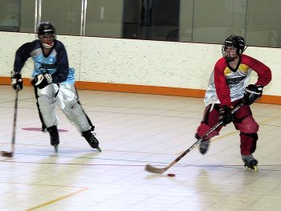

7. A bicyclist accelerates –0.87 m/s² during a 3.8 s interval. What is the change in the velocity of the bicyclist and bicycle?



